EIS Student Survey 24-25
Responses: 91
Average time to complete: 53:18 minutes
MYP1
- I feel respected by my classmates:
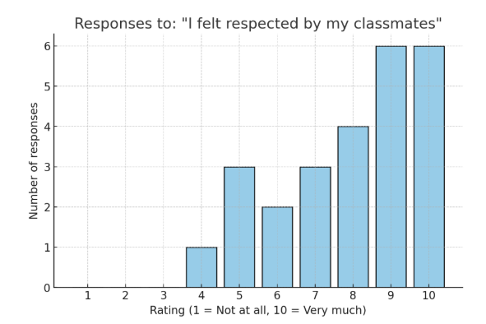
- What is the main reason for your score?
Glows: Positive comments
Grows: Areas or improvement
Glows summary:
- People are generally nice, respectful, and helpful.
- Many have made good friends and feel listened to.
- The class environment is often fun and supportive.
Grows summary:
- Some experiences of disrespect, rude jokes, or people talking behind their backs.
- Moments of feeling left out, worried about mistakes, or occasional arguments.
- Respect and kindness sometimes depend on individual moods.

Chart with responses:
Glows (Positives) | Grows (Areas to Improve)
People are nice overall | Sometimes people are not that nice
They don’t cross boundaries | Felt a bit left out during some games at break
People are very nice at school | Slightly disrespected sometimes for opinions
Everybody was nice | Afraid of making mistakes, worried about being made fun of
Classmates are pretty respectful | Respectfulness varies depending on mood/classmate
Feel respected in class and it’s fun | Some people talk behind back
Made a lot of nice, respectful friends | Not respected by some, e.g., comments undermining confidence in football
Talk to almost everyone in class | Sometimes people make rude jokes (even if they stop when told)
People listen to what I say | Occasional arguments with classmates
Classmates listen and help improve ideas
Friends were respectful
Classmates are very kind (rating 9/10)
Feel respected quite a lot (picked 9/10)
Everyone knows each other and has fun
Have a lot of friends

- I feel safe speaking up or sharing my thoughts in Homeroom
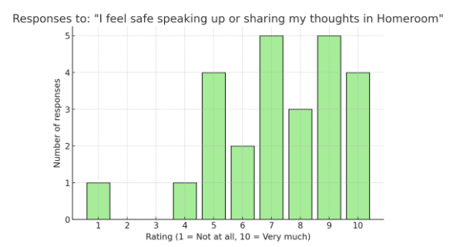

- What is the main reason for your score?
Glows: Positive comments
Grows: Areas or improvement
Glows summary:
- Many students feel supported, unjudged, and safe sharing their thoughts.
- They appreciate that mistakes are treated kindly and classmates/teachers help them improve.
- Some students are very comfortable sharing and don’t see a reason not to.
Grows summary:
- A noticeable group still feels shy, scared of judgment, or hesitant, often due to overthinking or fear of making mistakes.
- Some specifically mentioned being nervous or feeling their classmates might not have open minds.
- A few keep more personal thoughts private by choice or only share certain topics.
Glows (Positives) | Grows (Areas to Improve)
None is offensive. | I am kind of scared of sharing my thoughts.
Because they are open and understanding. | Sometimes I can be a bit scared to share my opinion in class because I'm scared I will be judged.
Because I know nobody is going to make fun of me. | The same as my previous answer that I think that I might get some disrespect in my homeroom.
I really like sharing my thoughts. | People do not have very open minds.
I don't know why I would not feel safe.
I can share my thoughts without any problem. | Yes, but I get a little scarry.
7 because if I get it wrong my classmates help me understand how to do it. | The homeroom teachers were nice so I was more open but I still am working on sharing my thoughts.
Because if I do a mistake my classmates and teacher will help me understand it. | Try to keep it in between, I'm not gonna share everything about my life, only relevant stuff; with friends I'm willing to share private thoughts.
Because I felt safe there because there were teachers. | It's not the teachers' fault, I just overthink and don't really ask when I need help, it's something I have to figure out myself.
I answered 9 because when I mess up something when I present they don't point it out. | Because I don’t want people to judge me based off my thoughts. It is not their fault, just personal.
I usually speak to my parents about it but I do feel safe to share my thoughts. | The reason I put an 8 is because sometimes I think maybe some people might judge me so sometimes I don't share everything.
Yes, why would I not feel safe. | I feel safe saying them, I'm too shy to say it.
Because everyone is supportive.

- Do you feel that your Homeroom teacher cares about you? Yes, No, why?
- Most students feel that their Homeroom teachers care about them. They mentioned that the teachers show care by listening, checking in on how they’re feeling, helping when there are problems, and creating a safe, supportive environment.
- Some noted that the teacher tries to stop negative behavior like judgment among classmates.
- Do you feel respected by your Homeroom teacher? Yes, No, why?
- Most students said “Yes”, feeling respected because the teacher(s) treat them fairly, listen to their ideas, show empathy, encourage them, and respect their boundaries. Many appreciated the kindness, honesty, and care shown by the teacher(s).
- Several mentioned that the teacher tries to make things fair, helps them when they struggle, and creates a safe environment.
- A few responses were mixed, pointing out moments when the teacher could yell.
- Overall, the majority feel valued and respected, but there is some room for improvement in consistency and tone.

- What did you enjoy the most about Homeroom this school year?
- Silent speed ball was by far the most popular highlight, mentioned by many students. They enjoyed playing it on Fridays, found it fun and competitive, and appreciated it as a good brain break. Several specifically mentioned silent speed ball competitions or tournaments.
- Making new friends and meeting classmates from different countries was also something students enjoyed.
- Talking with friends and sharing about life, holidays, or weekends was appreciated.
- A few students mentioned the general fun or playful atmosphere, including the class’s “usual naughtiness.”
- Other memorable activities included starting a book together as a class, a mental health day, and enjoying various fun activities and competitions beyond just speed ball.

- What could make Homeroom a better place for everyone?
- Respect and kindness were the most common themes. Many students want everyone to be nicer, more respectful, less judgmental, and have an open mind so activities can happen more often without conflict.
- Several students expressed wanting the silent speed ball competition back regularly, as it’s something that brings fun and togetherness.
- Some suggested more interactive activities and giving students more choices/options in the morning, including time to hang out or get ready for class.
- A couple mentioned using the idea box more to gather suggestions.
- Others felt homeroom is already good or “perfect in its own twisted way.”

- Are there any topics or activities you wish were part of Homeroom?
- Many students said “no” or were happy with Homeroom as it is, indicating they didn’t feel anything was missing.
- Several suggested playing more games, including:
  - More silent speed ball or bringing back the competitions.
  - Different fun learning games, like Blooket or general gaming.
  - Drawing or having quiet time on Fridays.
- Some wanted to go outside more for fresh air or to have snack time inside when it’s cold or rainy.
- A few suggested talking about current events or the news more often.
- One student mentioned having optional study time on days other than Wednesday, for anyone who needs it.
MYP 2
- I feel respected by my classmates:
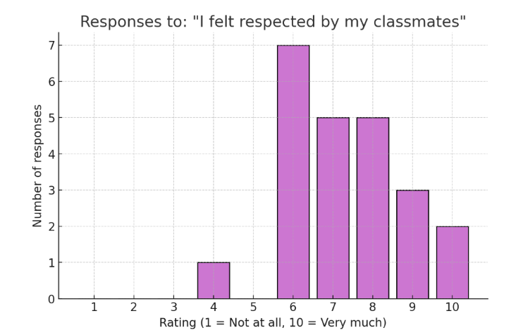
- What is the main reason for your score?
Glows: Positive comments
Grows: Areas or improvement
Glows:
- Most feel they can talk freely, have good friendships, and generally experience respect.
- Classmates listen, interact well, and many enjoy the social atmosphere.
- Minor conflicts happen but don’t overshadow the positive environment.
Grows:
- Some report rudeness or feeling judged by peers.
- There are mentions of selfishness, group division, and occasional disrespect.
- Some feel less comfortable or not fully respected at times.
Chart with responses:
Glows (Positives) | Grows (Areas to Improve)
I can talk with them and not feel scared. | Some people aren't very nice.
They were nice but sometimes can be a bit annoying. | Sometimes they were rude and sometimes they were nice.
Sometimes they were rude but in general nice enough. | The class could be less selfish and there is grouping up and trash talking.
I think our class is respectful but we could work on it more. | I just don’t feel respected.
I haven’t been treated badly and I have friends in my school. | Some judge me.
I feel respected and have a good relationship with most classmates. | Sometimes classmates don’t respect me, but most of the time they do.
I like talking to classmates regularly; minor conflicts but overall good. | Sometimes I don’t show a lot of comfort with them.
I’m good with everyone. | —
Because they listen. | —
Because I talk with everyone and they talk back. | —
Because I feel I can talk in my class. | —
I have tons of good friends and enjoy being with them in class. | —
I made new friendships, and people were really nice and sweet to me. | —
I feel respected by my friends. | —
They were nice. | —
They’re nice and really fun. | —
— | I don’t know.

- I feel safe speaking up or sharing my thoughts in Homeroom
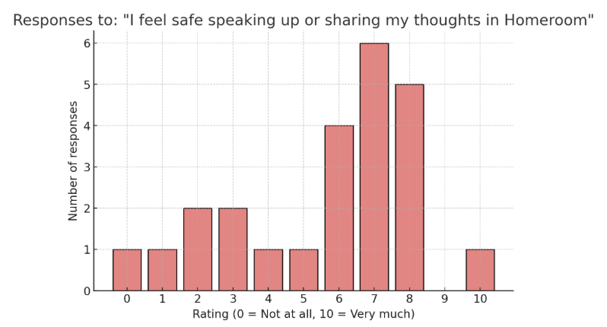
- What is the main reason for your score?
Glows: Positive comments
Grows: Areas or improvement
Glows:
- Many feel safe and respected in their homeroom environment.
- Listening and respect from peers/teachers are appreciated.
- Some enjoy talking in class and with friends.
Grows:
- Significant hesitation to share thoughts publicly due to fear of judgment or ridicule.
- Some keep thoughts to themselves or only share with close friends.
- Feeling that homeroom activities are lacking or not conducive to sharing.
- Social anxiety or awkwardness around speaking out loud is common.
Chart with responses:
Glows (Positives) | Grows (Areas to Improve)
I have never felt unsafe or disrespected when speaking up in class. | I would rather keep my thoughts to myself.
My homeroom is very nice. | They laugh and can easily make fun of someone.
Yes, because they listen. | I don't like speaking my mind to my class.
Because they respect me. | I feel safe but at the same time I think people are judging me.
Because I feel I can talk freely in my homeroom. | I don't care anymore what people think.
The reason I chose this score is because I always talk with everyone in my class and it’s fun. | Yes, because we are not doing anything in homeroom.
I often talk at my table. | I don't like giving private information to almost anyone.
I feel safe sharing my thoughts with only my very close friends in homeroom. | Kind of, but I don't like to speak out loud.
— | People are too judgy.
— | It’s just so awkward.
— | I didn't really want to share my thoughts.
— | I don't really share anything.
— | Same as previous answer (related to hesitance).
— | I don’t know.

- Do you feel respected by your Homeroom teacher? Yes, No, why?
- Most students in MYP2 feel respected by Miss Jess.
- They describe her as kind, caring, nice, and someone who listens and respects diversity.
- Many feel comfortable and say they’ve never felt disrespected or that their opinions are always considered.
- A few students were more in-between, saying “sometimes,” “kind of,” or “I would say yes and I'm not sure,”
- Overall, teacher creates a respectful, inclusive environment where students generally feel valued and heard.
- Most students in MYP2 also feel respected by their homeroom teacher, describing them as very nice, respectful, happy, and kind.
- Some students feel very comfortable sharing things that make them uncomfortable, which shows trust.
- There were a couple of more neutral responses such as “a bit in between” or feeling like “just a normal student,” suggesting occasional uncertainty about being especially valued.
- Still, most comments reflected a sense of being listened to, smiled at, and having their opinions considered, showing a generally positive and respectful environment.

- Do you feel that your Homeroom teacher cares about you? Yes, No, why?
- Most students in MYP2 also feel that their homeroom teacher cares about them.
- They noted that she is nice, listens to them, checks on how they feel, ensures their work is done, and makes sure ideas are heard.
- A few students felt less certain, mentioning there are many students so it’s hard for her to care about everyone. One student also pointed out a sense of power difference between teachers and students.
- The majority see her as caring and attentive, taking time to look out for them individually.
- Overall, students generally feel cared for, even if some recognize the challenge of being one student among many.
- Most students in MYP2 feel that their homeroom teacher cares about them.
- They describe her as nice, respectful, kind, and someone who takes time to listen and answer questions.
- Some shared specific examples, like the teacher checking on their well-being, making sure ideas are heard, warning them about risks in experiments, and generally being supportive.
- A few responses were broad, like “kind of…” or “I think she cares about everyone, so I don’t really know,”.
- Overall, students feel comfortable, listened to, and believe their teacher cares about them and the whole class.

- What did you enjoy the most about Homeroom this school year?
- Community circles:
This was by far the most mentioned highlight. Many students said they enjoyed community circle sessions, and noting how it helped them connect or start the day positively.
- Spending time with friends:
Many students enjoyed simply talking, chilling, or having weird conversations with their friends during homeroom. Some also mentioned enjoying playing games, card games, or doing activities together.
- Special events and activities:
A few students highlighted Week Without Walls as a favorite because it let them spend time with their classmates in a fun way. Others enjoyed various games and activities done in homeroom.
- Freedom and relaxed environment:
Some appreciated the freedom and chill time homeroom offered, like having time to do nothing, chat, or ease into the day.

- What could make Homeroom a better place for everyone?
- Many students suggested having more activities, games, or a greater variety of things to do, instead of mostly reading or working.
Ideas included:
  - Board games or card games
  - Coloring or art activities
  - Assigned days for playing games
  - More interactive activities to start the day.
- A large number of students said they would like no more DEAR (reading) time during homeroom.
They preferred using that time to:
  - Do school work,
  - Watch a movie, or
  - Have more flexible activities.
- Several mentioned wanting a more comfortable environment
  - Lower voices / less shouting, so everyone feels heard during discussions or community circle.
  - Flexible seating and the ability to sit next to friends.
  - Opportunities to connect more with the other class.
- A few students also mentioned wanting more people in the class for more social interaction. Simply making sure people feel comfortable and happy.

- Are there any topics or activities you wish were part of Homeroom?
- More community circle & free time
- Extra time to talk and catch up with friends.
  - Interactive or fun activities:
  - Board games on certain days
  - More fun games in general
  - Watching a movie
  - Doing activities outside
- Special seasonal ideas:
  - Decorating for Christmas
- Learning topics:
  - Maybe history of a sport (though they were unsure)
- Snacks or drinks:
  - One student suggested having snacks or drinks in homeroom.

MYP 3
- I feel respected by my classmates:
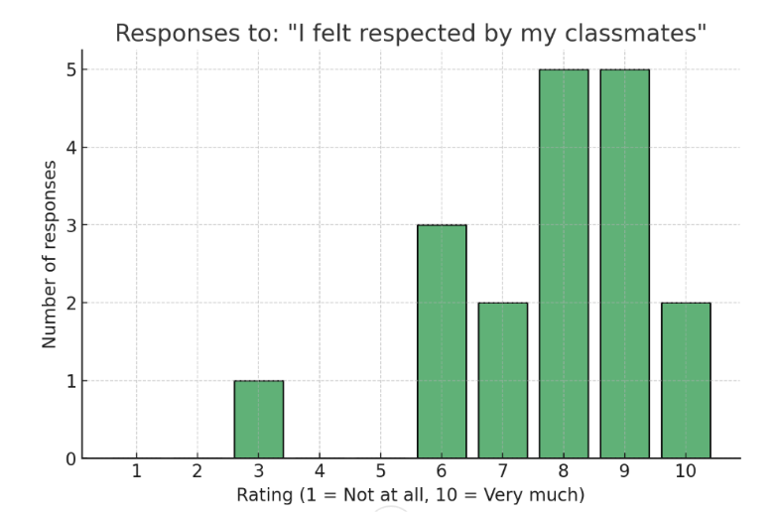
- What is the main reason for your score?
Glows: Positive comments
Grows: Areas or improvement
Glows summary:
- Most feel their classmates are respectful, kind, and friendly.
- Many value having lots of friends, being able to speak their opinions, and enjoying time together.
- The year was overall fun and positive for these students.
Grows summary:
- A few noted occasional teasing or joking that could still hurt.
- Some classmates talk instead of working, or enjoy mildly annoying behavior.
- Rare moments where people are not as kind as they could be.

Responses chart:
Glows (Positives) | Grows (Areas to Improve)
Because my classmates are very respectful. | Once in a while you get a bit teased in class but it is okay.
Because I'm not really rude to anyone. | A lot of them just talk and don't really work that much.
I feel respected and listened to by my classmates. | Some classmates enjoy annoying me.
Because they are nice. | Sometimes you can joke around and still be hurt a bit.
Because they were respectful. | They can sometimes treat you not so kindly.
Friends. | —
It was a fun year, I had fun with my classmates (fun part - everything). | —
Because I feel I can say my opinion. | —
Because I feel respected by my classmates. | —
I have a lot of friends in the class. | —
I can speak freely and share ideas and I won’t get judged. | —
All my classmates are really kind and I have a lot of fun with them. | —

- I feel safe speaking up or sharing my thoughts in Homeroom
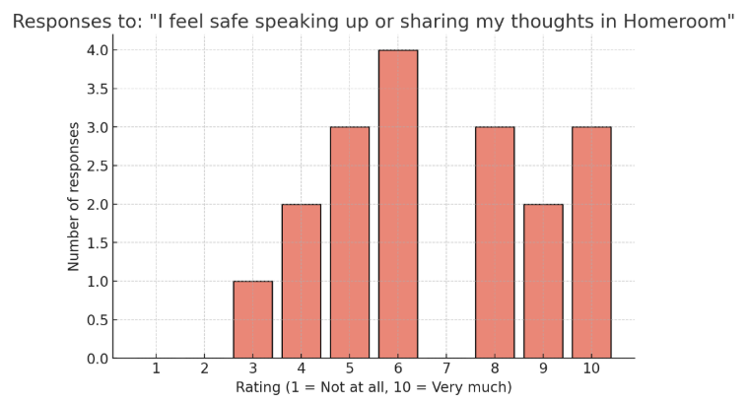
- What is the main reason for your score?
Glows: Positive comments
Grows: Areas or improvement
Glows summary:
- Many feel safe, understood, and respected, able to share thoughts without fear of judgment.
- Classmates are generally nice, get along well, and listen to each other’s answers.
- Students appreciate a supportive environment that encourages sharing.
Grows summary:
- Some are shy, not confident, or uncomfortable speaking up, especially in front of groups.
- A few mentioned fear of being criticized.
- Even when people talk a lot, it can make it harder for others to share.
Responses chart:
Glows (Positives) | Grows (Areas to Improve)
Because I feel safe and understood. | I don't like public speaking.
Because there is nothing to be afraid of. | Because I'm a little shy.
Everybody gets along well together. | I just don’t feel comfortable talking in front of people generally.
Because they are nice. | I am afraid of saying something wrong, even though I know I won’t get made fun of.
I was not afraid of saying my opinion. | Even since people talk a lot, sometimes it’s harder to share thoughts.
I feel everyone listens and respects each other’s answers. | I do not like to speak up in homeroom, but if I did I would feel safe.
Because I feel safe speaking up and sharing my thoughts in homeroom. | Not confident enough.
I can share ideas and I won’t get judged. | Sometimes you’re just not comfortable.
— | They sometimes criticize you.
—

- Do you feel respected by your Homeroom teacher? Yes, No, why?
- Most students in MYP 3 feel respected by their homeroom teacher.
- Reasons include:
  - She isn’t rude, and the respect is mutual (“she isn’t rude to us and we aren’t rude to her”).
  - She is always smiling, funny, and nice to everyone.
  - She looks out for the best interest of everyone.
  - She doesn’t disrespect students.
- Most students in MYP 3 also feel respected, saying:
  - She is kind, nice, fun, and a good teacher.
  - She pays attention to students and does activities to make it fun.
  - She prioritizes students, is respectful even on tough days, and they enjoy laughing with her.

- Do you feel that your Homeroom teacher cares about you? Yes, No, why?
- Most students feel respected and cared for by their homeroom teacher. They mentioned:
  - She checks on how they’re doing with their work.
  - She asks for their opinions and thoughts on different topics.
  - She listens to the class and follows what they say.
- One student noted: “She cares as much as a teacher should.”
- The majority also feel respected and cared for.
Highlights included:
  - She often asks how their weekend was or how their day has been, even if they’ve seen each other all day.
  - She does fun activities in homeroom, making sure they aren’t bored.
  - She prioritizes students, treats everyone equally, and takes pride in her work.
  - One student noted she cares about them lightly, so it doesn’t feel forced or overdone.
  - Another appreciated that she keeps them occupied with games and activities.

- What did you enjoy the most about Homeroom this school year?
- Many students highlighted enjoying the fun games they played together in homeroom: “Games”, “Fun games during homeroom”, “All the different games we played in the morning.” Specific examples included:
  - Scribble sessions
  - The murder game
  - Small activities & challenges before events
- Others enjoyed small games and talking, and the chance to play games all together and socialize.
- Several students appreciated the time to spend with classmates and the homeroom teacher, mentioning: “I think it was fun to spend time with my classmates and homeroom teacher.” “Playing small games and spending time with my HR teacher and classmates.”
- They liked being able to mix with the other homeroom, saying: “I like that we get to be with the other homeroom so much.” “We can go to the other homeroom and spend time with them.”
- Some enjoyed the overall class spirit and atmosphere, especially during special periods like: Holidays, Christmas events, and end-of-year activities.

- What could make Homeroom a better place for everyone?
- More time, freedom, or flexibility
- More time overall & better environments.
- Being able to go outside earlier, not having to wait until a specific time.
- No DEAR time, which some feel takes away from flexibility.
- Playing small games to build relationships with classmates.
- Using phones to play games together, socialize through video games (noting that other schools allow it).
- Everyone getting along with each other.
- People being more accepting.
- Having the whole MYP3 together in one homeroom or being one whole class.

- Are there any topics or activities you wish were part of Homeroom?
- More time or activities with the other class.
- Gaming
- Playing games on phones.
- Playing Blooket.
- Playing football outside.
- Learning about conflicts in the world

MYP 4
- I feel respected by my classmates:
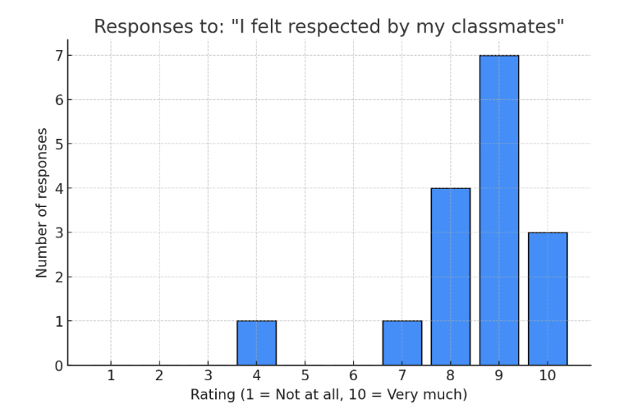
- What is the main reason for your score?
Glows: Positive comments
Grows: Areas or improvement
Glows summary:
- The class environment is generally positive, friendly, and respectful.
- Students feel safe, close, and able to talk, with classmates who help when needed.
- Many highlighted mutual kindness and willingness to support each other.
Grows summary:
- A few mentioned it can get boring at times, or that there’s occasional laughing that might feel uncomfortable.
Responses chart:
Glows (Positives) | Grows (Areas to Improve)
We have a good class energy and respect each other. | It’s a great environment but it can get boring.
Because I feel relatively respected by them. | Occasional laughing at me/with me.
They are all very friendly to me and if I ask for help they will try their best. | —
Because they respect me. | —
We all get along quite well. | —
We all get along. | —
Because they are respectful. | —
I feel close and safe in my classroom environment. | —
Everyone is very nice. | —
Because my classmates are respectful. | —
Cause I feel respected. | —
Because they let me talk. | —
All of us are kind to each other and help each other. | —
Because we help each other when anyone needs help. | —
— | I don't know.

- I feel safe speaking up or sharing my thoughts in Homeroom
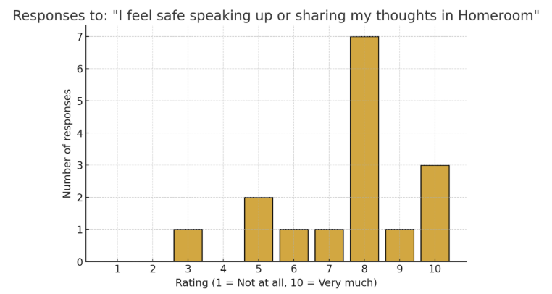

- What is the main reason for your score?
Glows Summary:
- Most students feel comfortable, supported, and not judged in their homeroom.
- There is a strong sense of trust and positive peer relationships.
- Community Circle and class culture help create a safe space for sharing.
Grows Summary:
- A few students don’t share often, either by choice or because they haven’t had to.
- One student said "no one is listening to me", indicating a possible need to improve attention and inclusivity.
- Some choose to filter what they share, suggesting that while the space is safe, full openness may still be limited.
Responses chart:
Glows (Positives) | Grows (Areas to Improve)
I feel like I am definitely able to share my opinion in homeroom. | It's not like I would want to share everything there.
Sharing my thoughts is extremely easy in my HR, debates happen but nothing problematic. | Don’t do it often.
Because my friends and classmates are very supportive. | I don’t really know because I haven’t had to.
No one really judges. | No one is listening to me.
I feel like nobody will judge. | —
I feel comfortable with my class. | —
I feel confident around my class. | —
Because I don’t feel judged. | —
Because I trust my classmates and they're supportive. | —
If it is important then I would share it, but if unnecessary then I won’t. | —
Because of community circle. | —
I am comfortable in our class and we do not judge each other. | —
Because our class does not make fun of people if they share opinions. | —

- Do you feel that your Homeroom teacher cares about you? Yes, No, why?
- Most students again say “Yes,” they feel respected.
- They note that the teacher:
  - Listens to their thoughts and explanations.
  - Validates their experiences.
  - Is kind and wants to hear from everyone.
- “Yes. No answer really, just he does I guess.”

- Do you feel respected by your Homeroom teacher? Yes, No, why?
- Most students feel respected by their homeroom teacher. They appreciate that he:
  - Listens to their ideas and questions.
  - Is polite, kind, and open to everyone’s voice.
  - Helps them when needed.
  - Builds a good bond with them.
- Some said, “No and yes,” or “Both,”

- What did you enjoy the most about Homeroom this school year?
- Many mentioned enjoying the chance to talk, share thoughts, laugh, and connect with classmates during community circles.
- Students appreciated being able to spend time chatting and hanging out with friends in a casual and calm environment.
- Some liked having time to do work as well as free time to relax and socialize.
- Several students noted that the overall calm atmosphere made Homeroom enjoyable.

- What could make Homeroom a better place for everyone?
- Students appreciate community circles, especially when topics aren’t always serious and allow for fun participation.
- Many want to choose their own seats instead of assigned seating to feel more comfortable.
- Suggestions of more games and interactive activities, like Kahoot quizzes, especially “Who did” or “Who said” type games involving classmates.
- Students want more opportunities to spend time as a whole class for bonding and teambuilding.
- Some suggested decorating the classroom according to the season or holidays.
- Letting students stay inside during snack or break time if the weather is bad.
- Some prefer fewer reflections to keep the mood light: Less frequent or no Thursday reflections.
- Making sure everyone is supportive and respectful of each other.

- Are there any topics or activities you wish were part of Homeroom?
- Some want more games, especially board games and Kahoot quizzes.
- A few suggested a running game that could last throughout the year.
- Many said no changes needed or they felt homeroom was satisfactory as it is.

